Nama : Valdez Bentiraz

Kelas : IF-46-11

NIM : 1301220276

TP PBO MOD 09

**CLASS SHAPE**

**CLASS RECTANGLE**

**CLASS CIRCLE**

**INTERFACE HASVOLUME**

**CLASS TUBE**

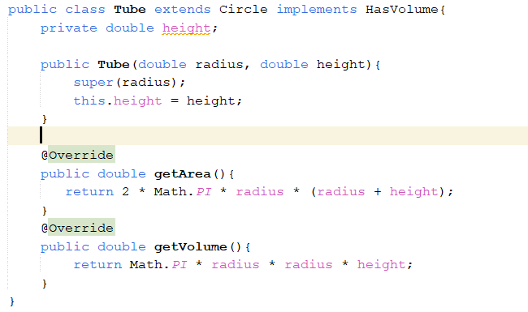

**CLASS SQUARE**

**CLASS CUBE**

**MAIN**

**OUTPUT**

